CP: 215
Weights and Bias:
Weights are value associated with the inputs that basically decides how much importance that particular input has on the desired output
Bias are a constant value that is added to the weight to offset the result
(e.g. input = 1
weight = 0.2
bias = 2.0
Output = (input * weight + bias))

Output layer: taking input from one of the Hidden layer not from sensors but still output the same stuff
output = inputs[0] * Weights[0] + inputs[1] * Weights[1] + inputs[2] * Weights[2] + bias

out = weight * input + bias similar to (as it is used to predict something)
y = mx + c
This is what's fed to the Rectified Linear Activation Function
Generally your hidden layers have a different activation function compared to your output layer
y = { x: x > 0 }
{ 0: x <= 0 }
* This would show the point that weights and biases, weights flipping the sign or biases offsetting enough in such a way
that you get this grandlier output

Sigmoid Functions: occurs after the out function has been executed
We use a Sigmoid function instead of just the step function because we will not find out how close we are from 0 or 1
with the Step function so we use sigmoid as it is more reliable to train

Why We use Sigmoid Function? pg 71
- if we just use weight and biases for our algorithm y = x linear activation all the outputs would be linear
if we try to fit a linear activation function to a non linear function like a sine wave it wouldn't fit
- Rectified Linear Activation Function(ReLU) would fit better even with the same hidden layers and amount of neurons as it
is almost linear

How does ReLU work: pg 72
- with a single neuron (increasing the weight will strengthen the input, then bias can offset the activation point moving it horizontally)
if we negate the weight we can flip the ReLU activation from determining how the input activates but instead how the input deactivates
- top 7 neuron pairs will be adjusted to fit the (sine)shape
whilst the bottom pair will solely work on offsetting the function
* That's why to fit non linear problems we need two or more hidden layers and with those two hidden layers that's why we use non linear
activation functions

^output of 1st neuron is starting point for 2nd neuron making interesting shapes

Input -> Exponentiate -> Normalize -> Output
( Softmax )

Dense layers/Fully-Connected: (most common layers) [page 10]
- consist of interconnected neurons
* In a dense layer, each neuron of a given layer is connected to every neuron of the next layer
- each connection has a weight associated to it which is a trainable factor of how much of this input to use (weight * input)
- once the inputs-weights flow into our neuron, they are summed and a bias is added
* purpose of this bias is to offset the output positively or negatively
{ y = mx + c }

Step Function:
- mimic a neuron firing/not in the brain.
if sum(inputs*weights) + bias is > 0 neuron fires
else neuron doesn't fire

^ Goal of all neural networks is to generalize, meaning the network can see many examples of never-before-seen data and accurately output the values we hope to achieve

Neural Networks take in many samples at a time for two reasons:

* faster to train in batches in parallel processing
* batches help with generalization during training

^ when doing a dot product of the inputs and weights with multiple neurons we would need to transpose(T) if the matrix are both the same (can't have inputs and weights same size {(3,4),(3,4) = N / (3,4),(4,3) = Y}

biases: pg 51

Activation Functions(68): two types of activation functions
1. used in hidden layers (Rectified Linear Activation Functions ReLU)
2. used in output layers

pg 90 for Rectified activation func on non linear diagram

Softmax Activation Function:

Multiplying Matrixes:
* Both matrixes need to have the same amount of columns:

{c1 3, 4, 6, 5 { 1 c1 x c1 [sum of all]
c2 9, 3, 6, 2 5 = c1 = 3 + 4 + 6 + 5 = 18
c3 1, 5, 7, 2 } 7 } c2 = 45 + 15 + 30 + 10 = 100
c3 = 7 + 35 + 49 + 14 = 105

exponents: pg 96

^ we exponentiate our outputs because some outputs might be negative which for a probability or confidence doesn't make sense so if we do -> outputs * e(Euler number e[2.71828182846 or math.e]) then non of the outputs would be negative as exponential numbers can't be negative {it returns 0 for negative infinity, 1 for the input of 0, and increases for positive values}
y = e^x
Calculating Network error with Loss: pg 107
* To train a model, we tweak the weights and biases to improve the model’s accuracy and confidence. To do this, we calculate how much error the model has. The loss function, also referred to as the cost function, is the algorithm that quantifies how wrong a model is. Loss is the measure of this metric. Since loss is the model’s error, we ideally want it to be 0.
* argmax accuracy cannot be used to calculate error as it’s accuracy is just from applying argmax[Maximum values along an axis] to the output to find the index with the highest value.
^ The output of a neural network is actually the confidence, we need to tackle misplaced confidence and increase correct confidence

Categorical Cross-Entropy Loss: pg 108
* used to compare a “ground truth” probability (y or “targets”) and some predicted distribution(y-hat or “predictions”), so cross-Entropy would be useful here.
Formula:
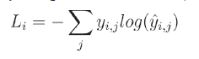
Ground Truth = checking the results for accuracy against the real world [an input given to the machine by the user to depict an outcome e.g. whether an image is a cat or not

L i = sample Loss value, i = i-th sample in the set, j = label/output index, y = target values and
y -hat = predicted values

Simplified further in code to:
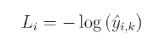
Where k is an index of “true” probability

^One-Hot Vectors are the desired outcome, meaning one value in the vector consists of 1(The desired class) whilst the rest undesired classes have a value of 0.
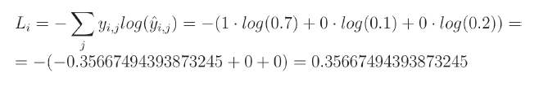
* When comparing the model’s results to a one-hot vector using cross-entropy, the other parts of the equation zero out, and the target probability’s log loss is multiplied by 1, making the cross-entropy calculation relatively simple. This is also a special case of the cross-entropy calculation called categorical cross-entropy.

^ Log = natural Log [ ln ]

Loss/confidence being Log(0): pg116
* if y = log(x) then e y =x
^ log(0) = -∞ (infinitely small x) [never reaches 0 but very close to 0]
for numpy log(0) always results in -∞ never undefined
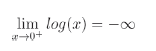

Np.e**(-np.inf)

* The fewer Undefined things the better

^ We could add a very small value to the confidence to prevent it from being zero, for example 1e-7

* np.log(1e-7) = 16.11809565095832
Adding a very small value, one-tenth of a million, to the confidence at its far edge will
insignificantly impact the result, but this method yields an additional 2 issues.
* -np.log(1+1e-7) = -9.999999505838704e-08
1. when the model puts all the confidence in the correct label, loss becomes a negative instead of being 0

2. shifting confidence towards 1, even if by a very small value
* To prevent both issues, it’s better to clip values from both sides by the same number, 1e-7 in our case.
* That means that the lowest possible value will
become 1e-7 (like in the demonstration we just performed) but the highest possible value, instead
of being 1+1e-7, will become 1-1e-7 (so slightly less than 1):

* -np.log(1-1e-7) = 1.0000000494736474e-07
This will prevent loss from being exactly 0, making it a very small value instead, but won’t make
it a negative value and won’t bias overall loss towards 1.
Within our code and using numpy, we’ll accomplish that using np.clip() method:

* y_pred_clipped = np.clip(y_pred, 1e-7, 1-1e-7 )

Accuracy Calculation:
* Accuracy is usually used alongside loss as it describes how often the largest confidence is the correct class in terms of a fraction. Argmax from the softmax outputs can be used to define accuraacy by comparing it to the targets.

# Accuracy Calculations [on code]

How to Adjust weights and Biases to minimize losses:
1. randomly changing weights and checking the losses. We repeat this until happy with lowest loss.
# Rando Weights and Biases – Takes far too long(too many iterations) to be an acceptable method.

2. Setting parameters with randomly-chosen values each iteration, apply a fraction of this values to parameters this way the weights will be updated from what currently yields us the lowest loss.
* If the adjustments decreases loss, we will make it to the new point to adjust from.
* If loss instead increases due to adjustments, then we revert to the previous point.
# Rando param WnB – Losses Decreased significantly and Accuracy increased greatly although after 100000 iterations there will not be much change present

Derivatives: pg 140 - 160
* f(x) = 2x

# Derivative Calc on Code
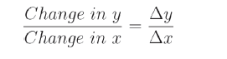

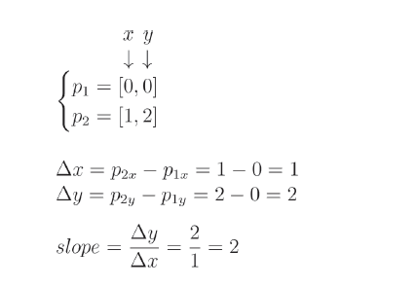

^ Adding small delta (0.0001) allows us to approximate the derivative between two very close points. This value allows the derivative to be as accurate as possible but large enough to avoid a rounding error.
- An infinitely small delta value will approximate an accurate derivative; however, the delta value needs to be numerically stable, meaning our delta cannot surpass the limitations of Python’s floating-point precision(can’t be too small as it might be rounded to 0)

* Prime notation derivative pg 151 f’(x)
f’(x) = 0
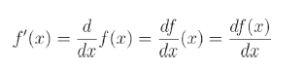

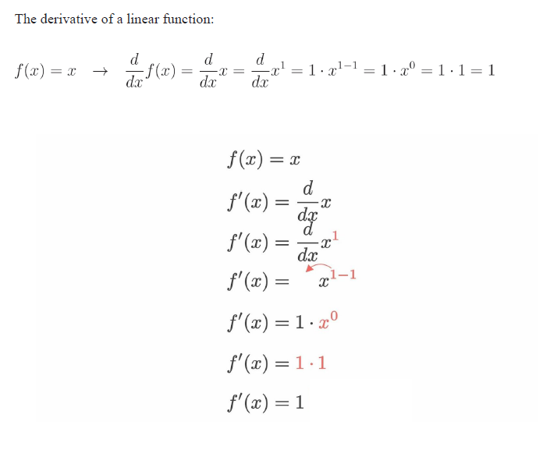

f’(x) = 1

^ When calculating the derivative, we can take any constant that function is multiplied by and move it outside the derivative (e.g. f(x) = 2x → f’(x) = 2

* Derivative of a constant = 0

Solutions for common Eq: pg 160-161
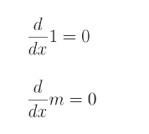

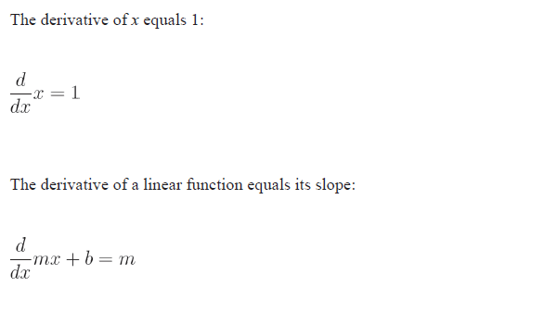

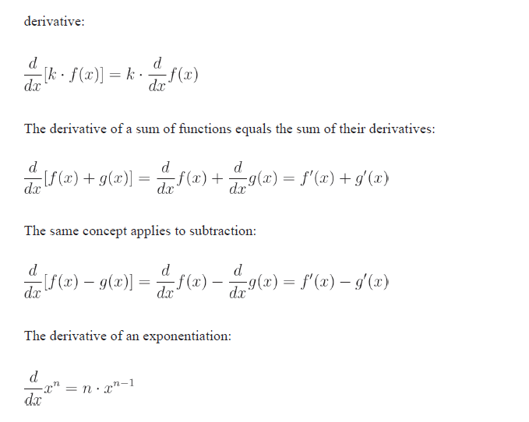

^ The derivatives that we’ve solved so far have been
cases where there is only one independent variable in the function — that is, the result depended
solely on, in our case, x.
However, our neural network consists, for example, of neurons, which
have multiple inputs. Each input gets multiplied by the corresponding weight (a function of 2
parameters), and they get summed with the bias (a function of as many parameters as there are
inputs, plus one for a bias).

Partial Derivative: pg 163-164
* measures how much impact a single input has on a functions output.
^ replace differential operator d with ∂
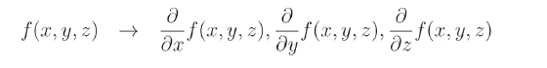

* calculating the partial derivative with respect to a given input means to calculate it like the regular derivative of one input, just while treating other inputs as constants.
- if focusing on x, y is constant therefore y = 0 | and vice versa
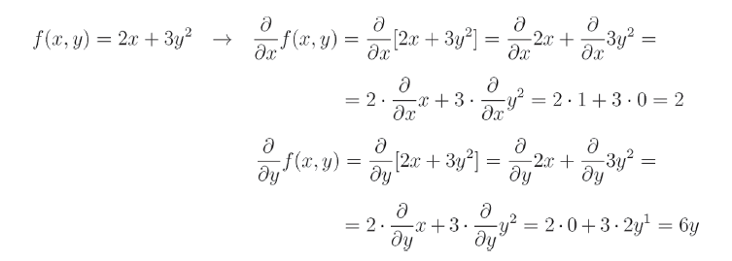
^ if we derive something with respect to x, which could be 1. The whole derivative results with y
[x·y] if derive something to y result = y·x (e.g. y = 2, x =3 result = 6)

Adding Multiplication of variables: pg166-167
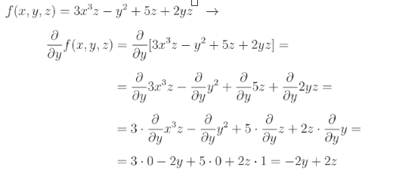

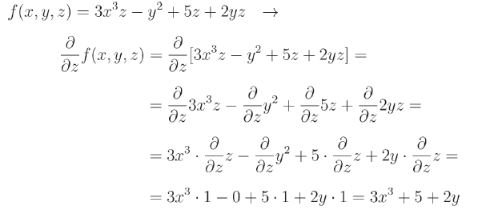

Partial Derivative of Max pg168
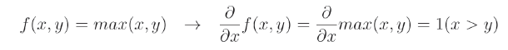

* the derivative of this function with respect to x equals 1 if x > y
else = 0 (if y > x)

^ one special case if we have only one variable parameter and the other parameter is always constant at 0. Useful for ReLU activation since function is defined as max(x, 0)
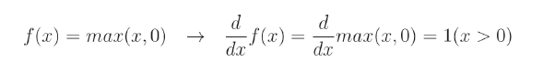

since it only takes a single parameter, we used d operator instead of the ∂ to calculate non-partial derivative. In this case, the derivative is 1 when x > 0 else result = 0

The Gradient (pg 169)
* The gradient is a vector composed of all of the partial derivatives of a function, calculated with respect to each input variable.
Looking back at previous partial derivatives:
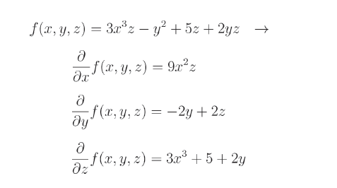

* We calculate all of the partial derivatives, we can form a gradient of the function:
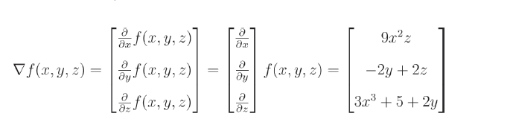

we denote the gradient as ∇- the nabla symbol
^ We’ll be using derivatives of single-parameter functions and gradients of multivariate functions to perform
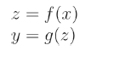
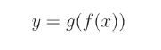
→

pg17 equation:
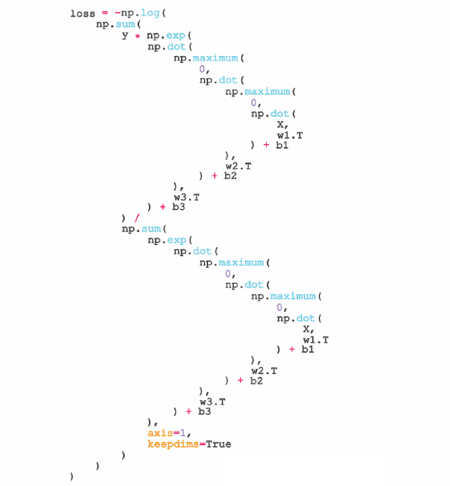

Chain Rule:
* we are representing loss as a big function that includes the whole neural network from inputs → hidden layer(activation funcs) → output/Softmax Activation → losses.
^ This is to improve loss as we would need to know how each weight and bias impacts it.

The rule states that the derivative of a function chain is a product of derivatives of all of the functions in this chain. For example:
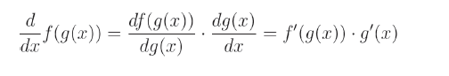

* with 3 functions and multiple inputs, the partial derivative of this function with respect to x is as follows (note we cannot use prime notation in this case since we have to mention which variable we are deriving with respect to):

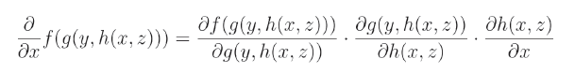

Summary of Derivatives, Partial, Gradient and chain funct - pg174

Back propagation: pg176 ~ #Backpropagation in code
* The first step is to backpropagate our gradients by calculating derivatives and partial derivatives with respect to each of our parameters and inputs. To do this we’re going to use chain rule.
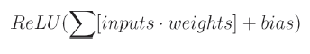

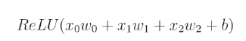

^ we need to figure out how much each input, weights and a bias impacts the output. We’ll start by figuring out what we need for the partial derivative of w0

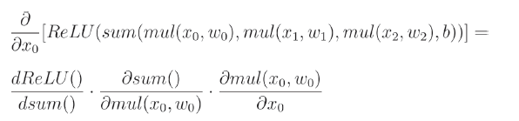

* Recall that if the derivative of ReLU() with respect to its input is 1, if the output it greater than 0, and 0 otherwise:
In code as:

relu_dz = ( 1. if z > 0 else 0. )

^ the partial derivative of a neuron’s function with respect to the bias is always 1
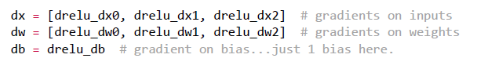

we can apply these gradients to the weights to hopefully minimize the output.

# Backpropagation with multiple neurons

Categorical Cross-Entropy loss derivative: theory – pg211-213

Softmax Activation Derivative – pg216- 221

Terms:
Transpose = rearrange the arrays input and weights
|First make the array into Numpy array(np.array) then Transpose by adding .T at the end

- Batch Size will alter the best fit line to best predict:
lower batch size will move around more when more data is given compared to a higher batch size

Sum, exp,

zip: iterate over multiple iterables simultaneously

* shape = what the size is at that dimension
Array: Shape:
1 = [1,5,6,2] (4,)

Type: 1D array, Vector
if simple list in python then its a
1D array in numpy and its a Vector in maths

Array: Shape:
lol = [[1,5,6,2], (2, 4)
(list of Lists) [3,2,1,3]]

Type: 2D array, Matrix(Rectangular Array)

Array: Shape:
lolol = [[[1,5,6,2], (3, 2, 4)
(list of Lists [3,2,1,3]]
of lists) [[5,2,1,2],
[6,4,8,4]],
[[2,8,5,3],
[1,1,9,4]]]

Type: 3D array

Tensor Flow: an object that can be represented as an array

Input = Vector
Weight = Vector
Bias = Vector

'row' dimension(2nd dimension) list:
- not homologous(each dimension is identically long) therefore can't be an array

pg98 axis = used for 2d array/matrix, axis 0 refers to rows, axis 2 refers to columns, axis = none all the values in the matrix/array

Arange() pg 143 – allows us to plot with smaller steps, np.arange() function takes in start, stop and step parameters; allowing us to take fractions of a step, such as 0.001 at a time

Keepdims – lets us keep the gradient as a row vector – recall the shape of biases array

np.eye – returns a 2-D array with ones on the diagonal and zeros everywhere
